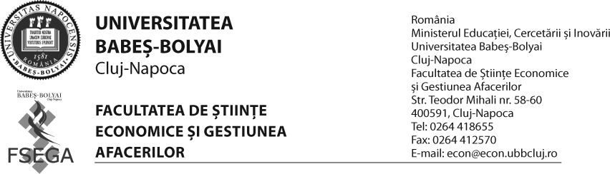

DEPARTAMENTUL DE LIMBI MODERNE ŞI COMUNICARE ÎN AFACERI
PROGRAMUL MASTER : TOATE SPECIALIZĂRILE
ANUL I
SEMESTRUL 2

PROGRAMA ANALITICǍ
An universitar 2011-2012

DISCIPLINA: LIMBA MODERNĂ ÎN AFACERI (LB. FRANCEZĂ)
1 oră de curs + 1 oră de seminar;

Tematica:

- Publicitate
- Finanţe publice
- Contabilitate
- Bănci
- Bursa
- Comerţ internaţional
- Asigurări

Bibliografia obligatorie

- *** English for Business and Administration, 1996, Cavallioti Publishing House
- Brieger, N., Sweeney, S. The Language of Business English: Grammar and Functions, Prentice Hall
- Chilver, J. English for Business: A functional approach, 1996, DP Publications
- Cotton, D. International Business Topics,1980, Nelson English Language Teaching
- Cotton, D. Keys to Management, 1980, Nelson English Language Teaching
- Cotton, D., Robbins, S. Business Class, 1993, Thomas Nelson and Sons Ltd.
- Flower, J. Build Your Business Vocabulary, 1990, Language Teaching Publications
- Goddard, C. Business Idioms International, 1994, Prentice Hall
- Howard-Williams, D., Herd, C. Business Words, 1992, Heinemann
- Jones, L., Alexander, R. New International Business English, 1997, Cambridge University Press
- Lannon, M., Tullis, G., Trappe, T. Insights into Business, 1993, Thomas Nelson and Sons Ltd.
- Mackenzie, I. English for Business Studies: A course for Business Studies and Economics Students, 1997, Cambridge University Press
- Radice, F. English for International Trade, 1982, Thomas Nelson and Sons Ltd.
- Sneyd, M. International Banking and Finance, 1992, Prentice Hall
- Vince, M., Advanced Language Practice, 1998, Macmillan Heinemann
- Vince, M, Intermediate Language Practice, 1999, Macmillan Heinemann
- Vince, M, First Certificate Language Practice, 1999, Macmillan Heinemann
- Wilson, M. Writing for Business, 1987, Longman

Titular de disciplină Director Departament
Lect. dr. Eugenia Irimiaş Conf. dr. Felicia-Delia Marga

